Introduction

This reflective essay explores the development of car dealership management software for ABC car traders. This management system is designed for both customers and administrators. The project is developed using C# and Visual Studio. This car management system demonstrates the implementation of a robust software architecture that includes user authentication, inventory management, order processing and report generation functionality. In this essay, we will focus on the technical aspects of the software, including the architecture of the software, class structure, and other critical features of the software. We will also dig into the development process and discuss the challenges encountered and the solutions implemented for this software. By examining this project's details, we aim to provide insights into the practical application of software development principles and the learning experience gained from this project.

Instructions to Run the Program
To run this project, we must set this project first. First, we must install the standard versions of MySQL and Visual Studio.
- After installing MySQL and setting up the MySQL server on the system, open the database folder and load the final database SQL script file to the MySQL server. After loading, run that SQL file.
- We update the database connection after successfully running the MySQL script in the open Visual Studio project. The cs file is located on the project root and updates the configuration according to the MySQL server configuration.
- After the configuration update, users can run the project
  - For Admin Side Login:
    - Username: admin
    - Password:admin123
  - For customer login, the user can register the customer and log into the system. Also, users can use predefined customer credentials.
    - Username: customer1
    - Password: customer123

Project Architecture
This project's architecture is structured to promote flexibility and maintainability. At the project root level, we have implemented the DatabsebaseConection file, which stores all the data connection logic and important methods like authentication users, registering users, and adding new cars and car parts. The database connection file will ensure a single management point for database interactions.
The core of the application is organised into two main folders
- Models
- Views
The models folder contains the primary classes of this application

- User. cs: Represents the user data
- CarPart.cs: Represents the car parts data
- IUser.cs: Interface defining the user properties
- Order. Cs: Manages order information, including nested OrderItem class and OrderStatus enum.
- Car. cs: Represent the vehicle data
The views folder is more subdivided to separate different user interfaces:
- Registration folder: Contains user registration views for signup
- Login folder: Contains login views for user-authentication
- Search Folder: Includes the search view for customers for product searching
- Car Folder: Include the views for adding a new car and view for viewing car details
- Car-part folder: same as car folder. It includes the views for adding new car parts and views for car-part details
- Order folder: Include the view for order details for the admin side
- User folder: Include the view for user details for the admin side
- Report folder: Include the view for report generation for the admin side
With views controlling user interaction and models handling data representation and business logic, this framework separates issues. Organising related UI components through subfolders within the Views directory makes the project easier to navigate and manage.

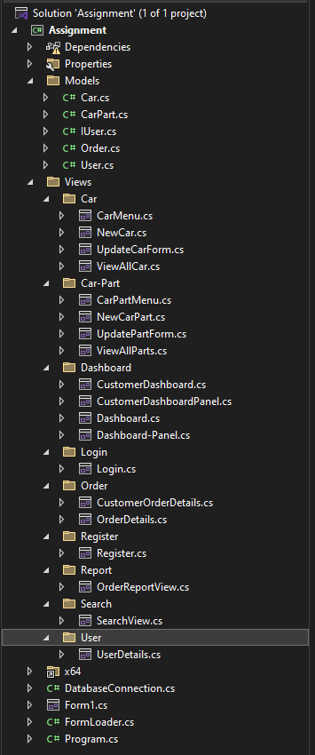

This architecture facilitates more accessible updates and extensions to the system, as each component has a defined purpose and location within the project structure.

Details Class Descriptions

This section will provide a detailed description of every essential class that forms the backbone of our ABC car dealership management system. These classes are necessary for representing data structures and implementing the core functionality.

- Car. cs
This class encapsulates the properties of the vehicle. It includes:
- CarID(int): A unique identifier for each car
- Brand(string): The manufacturer of the car
- Model(string): The specific model of the car
- Year(int): The manufacturing year
- Price(double): The selling price of the car
- StockQunatity(int): The number of units available in inventory
- User. cs
This class contains the user's properties. It includes:
- UserID(int): Unique identifier for each user.
- Username(string): The user-chosen login name
- Password(string): The user-chosen password for the system
- FirstName(string): The user’s first name
- LastName(string): The user’s last name
- Email(string): The user’s email address
- Order. cs
This class manages order information and includes:
- OrderId(int): A unique identifier for each order
- UserId(user): The ID of the user placing the order
- UserFirstName(user): The first name of the ordering user
- OrderDate(DateTime): The date and time when the order was placed
- TotalAmount(double): The total cost of the order
- Status(OrderStatus): The current status of the order
- OrderItems(List<OrderItem>): A collection of items in the order

This class also contains a nested OrderItem class representing individual items within an order. The OrderStatus enum is also defined in the order states(Pending, Processing, Shipped, Delivered, Canceled)
- Car-Part. cs
This class contains the properties of the car parts. It includes:
- PartId(int): Unique identifier for each car part
- Name(string): Name of the car part
- Description(string): Small description of the car part
- Price(double): The selling price of the car part
- StockQuantity(int): The number of available car parts in the inventory

- IUser.cs
This class implements the interface for the user class.

Besides these main classes, the program included classes for every UI component. In these UI components, we have an event handler for this program. Some of the event handlers in this project are
- btnSearch_Click: This event handler is in the search view. This event is triggered when the search button is clicked.
- dgvResult_CellContentClick: Handles clicks on the data grid view cells.

These event handlers enhance the usability of the program.
For clear visaul class description we can provide a class diagram. The class diagram will
provide a clear visualization for viewers.

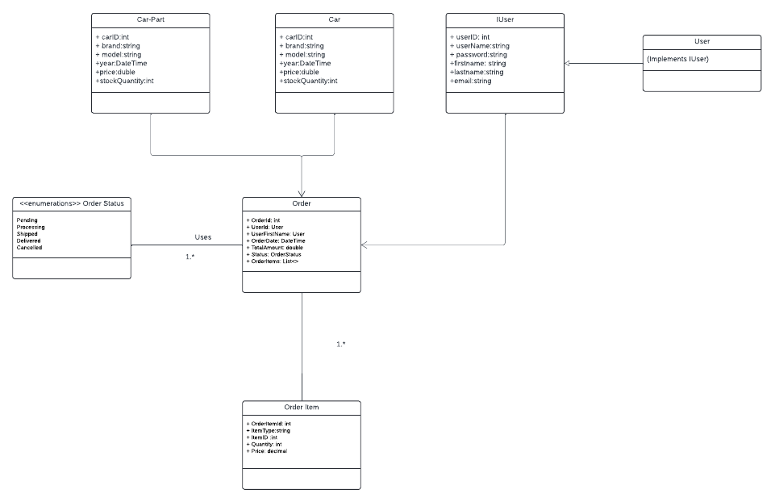
Activity Diagram
The activity diagram visual for this application will visualizethe sequence of operations occurs withint hte system for both user and administrators. It shows how how users interact with in the system, starting from the authentication for the system,buying cars and car-parts and processing orders . The activity diagram provides a clear understanding of how the sytem functions and helps in identyfyinh the potential areas for optimization or imporovment,Also activity diagram searves as a blueprint for developer and stakeholders.ensuring thet the system's processes are well-organized and efficient. Below activity diagram for user authentication, buying new car or car part , and order processing part diagrams are provided for readers.
- Activity diagram for Admin and Client Login
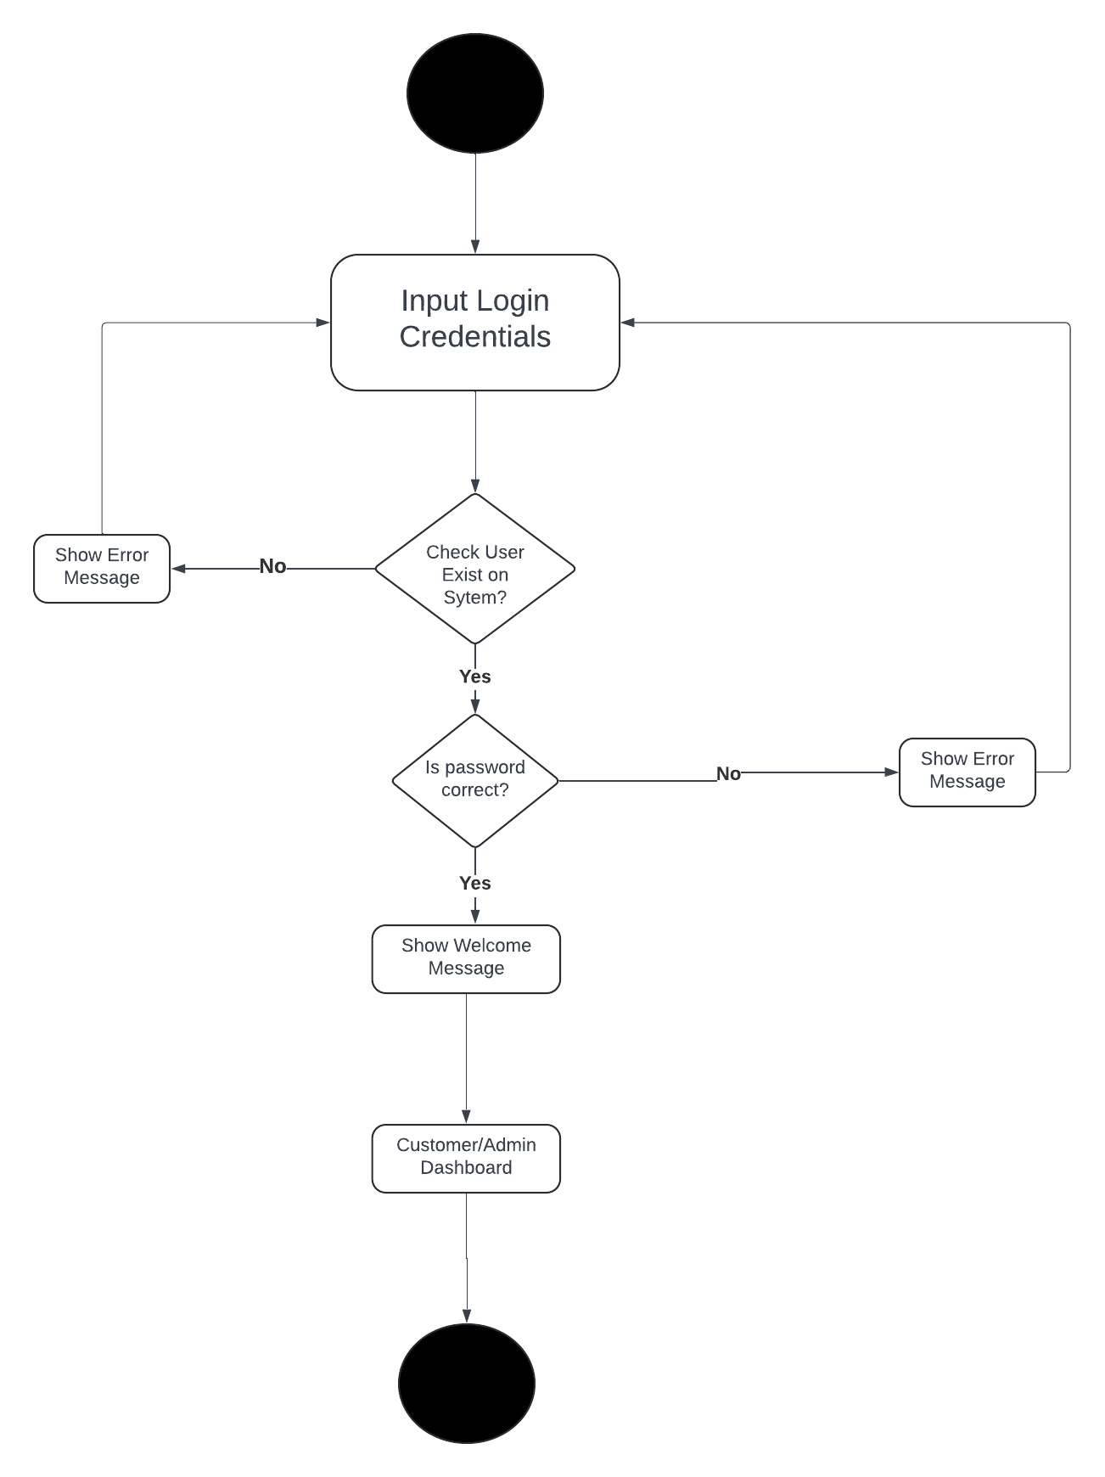

- Acitivity Diagram for buy car / car part

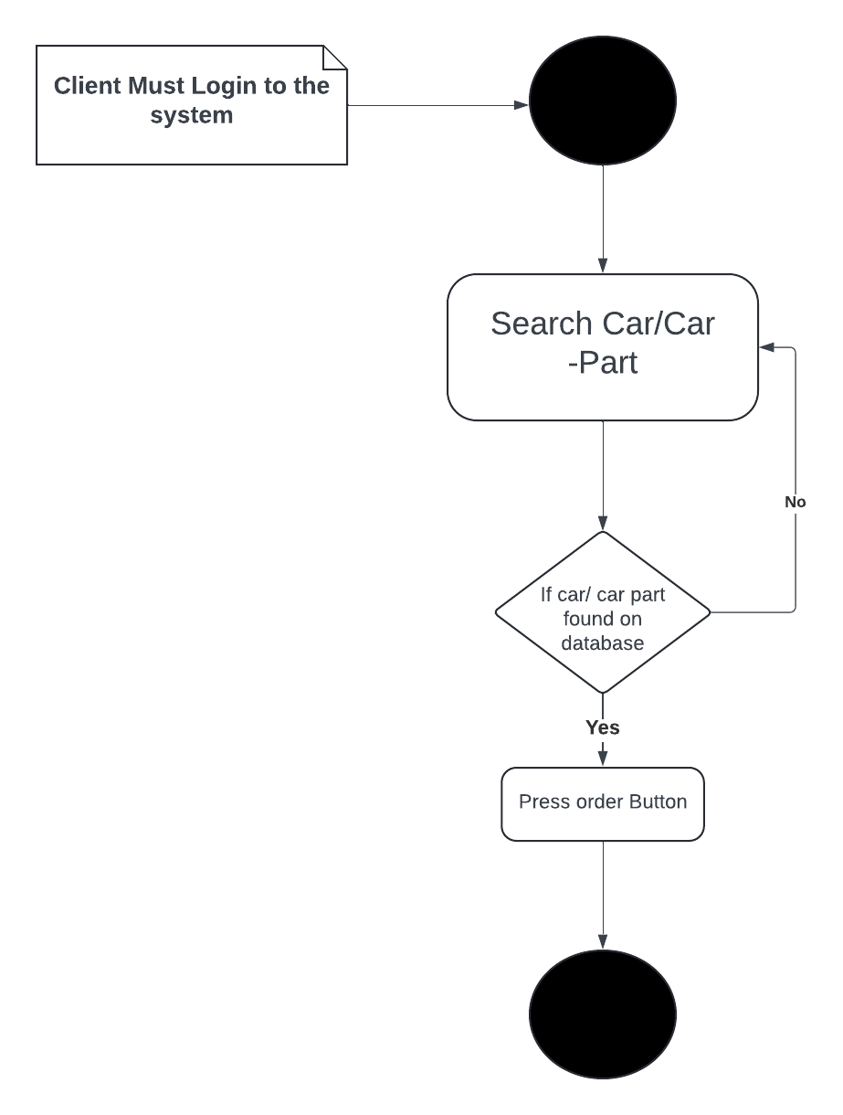
- Activity diagram for order processing operation

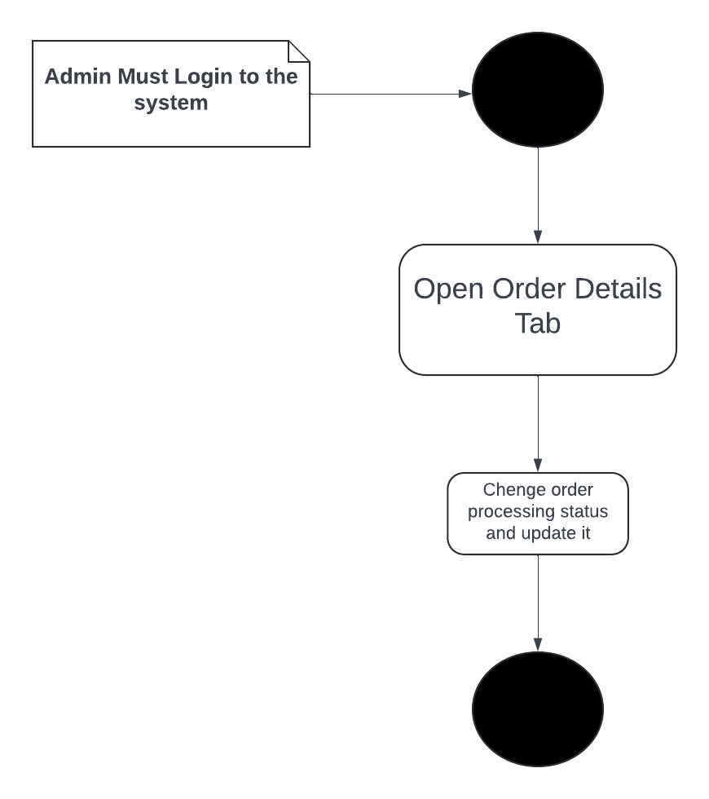

Sequence Diagram
The sequence diagram for this application offers a detailed voew of the interaction between users, administrators, and the system itself. It captures the flow of messages and events over time, illustrating how different entities communicate to complete various. The sequence diagram for this application is provided below for the readers
- Sequence diagram for users
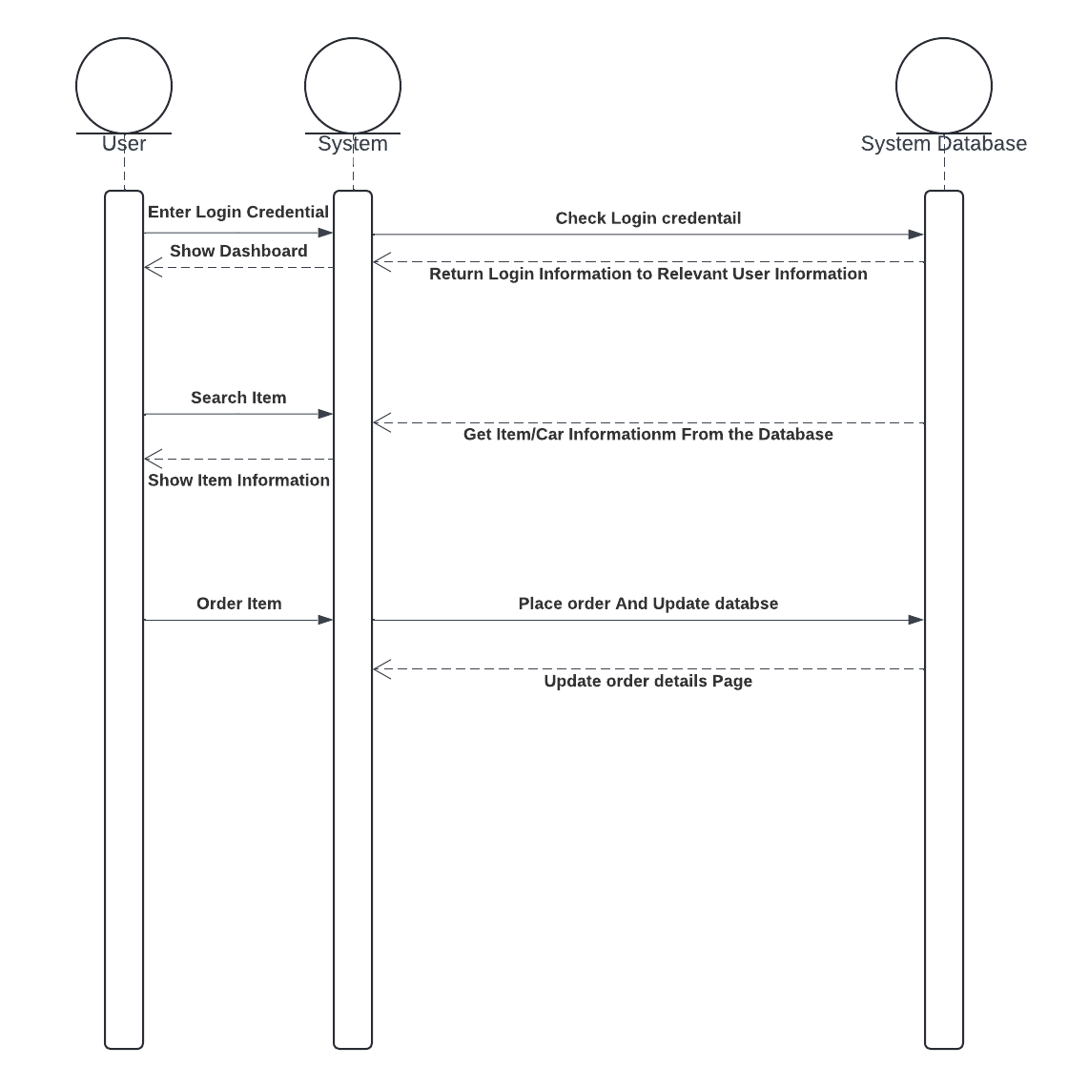
This sequence digram will provide clear definiton to viewer how the sytem is working in custmoer side.
Use Case Diagram
The use case diagram for this system will provide s a high level view of the functionalieties of a system and the interation between actors (user,administrator, and system) and functionalities .

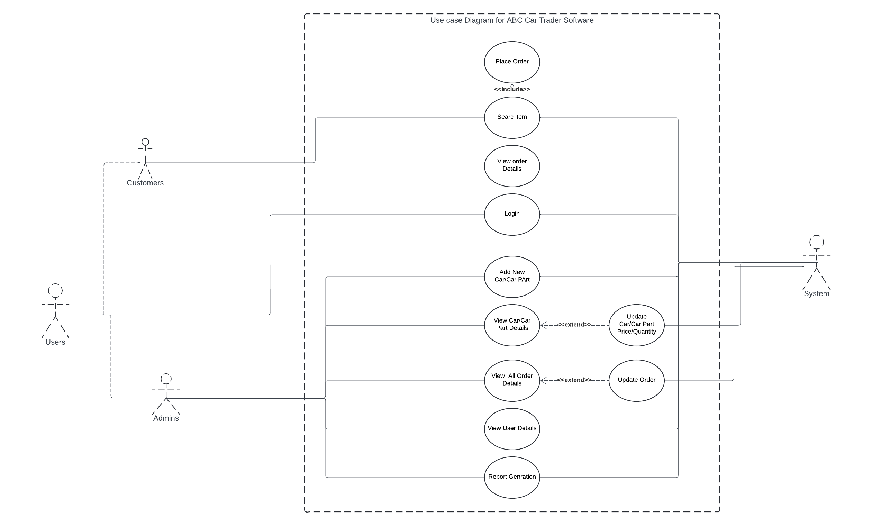

Reflection on Development Experience Using C# and Visual Studio
This project was developed with C# and Visual Studio, which offered a stable and effective environment for building a sophisticated application. The debugging tools and user-friendly interface of Visual Studio greatly expedited the development process. A clean, modular code design was made possible by C#'s object-oriented design, which is especially noticeable when creating classes like Order and Car. Because of the language's robust typing, errors were detected early on, and overall code dependability was improved—the MySql.The data package made integration with MySQL databases easy. However, becoming proficient with LINQ queries for database operations took some time. Overall, C# and Visual Studio worked together to create a scalable and maintainable vehicle dealership management system that balanced developer efficiency and performance.

Key Features of the System
This project has many vital features. The key features for this project are user authentication, user registration, adding a new car, viewing car details, adding new car parts, viewing car part details, searching items, adding orders, viewing order details, and report generation. For all of these functions, we have provided views in this program. All the screenshots of the views are provided below for your reference.

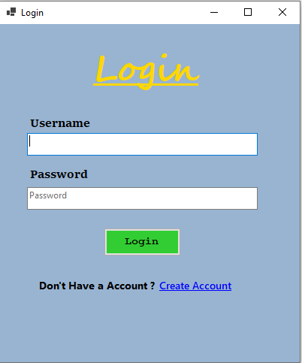

The above screenshot is the login view for the system.

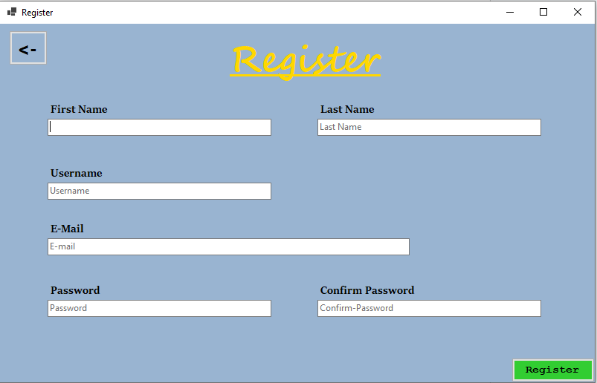

The above screenshot shows the user registration view.

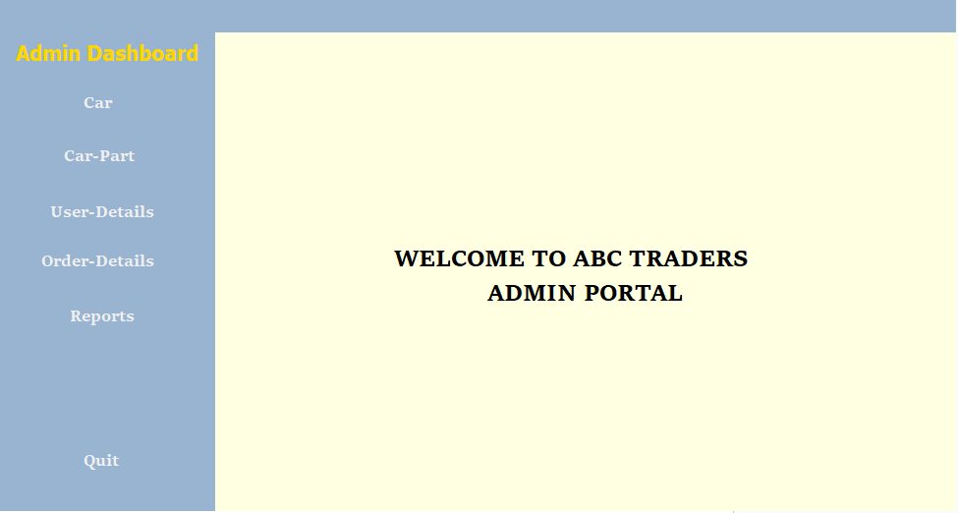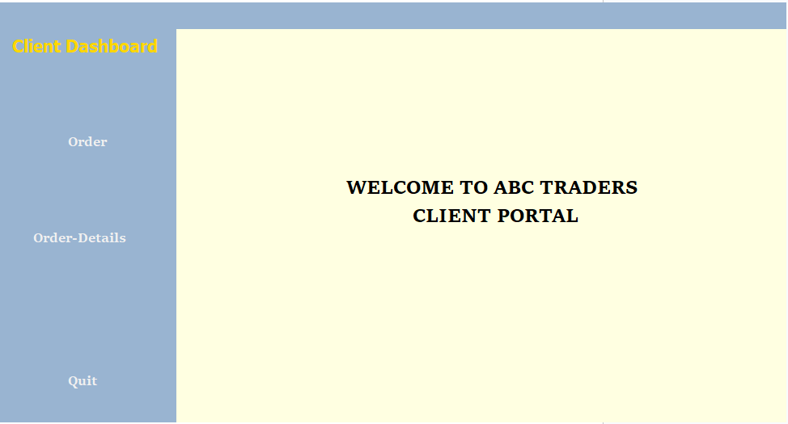

The above screenshots show the dashboard views for the client and admin.

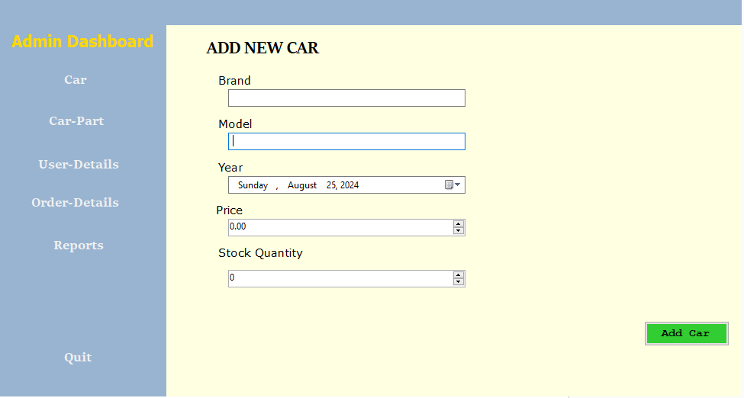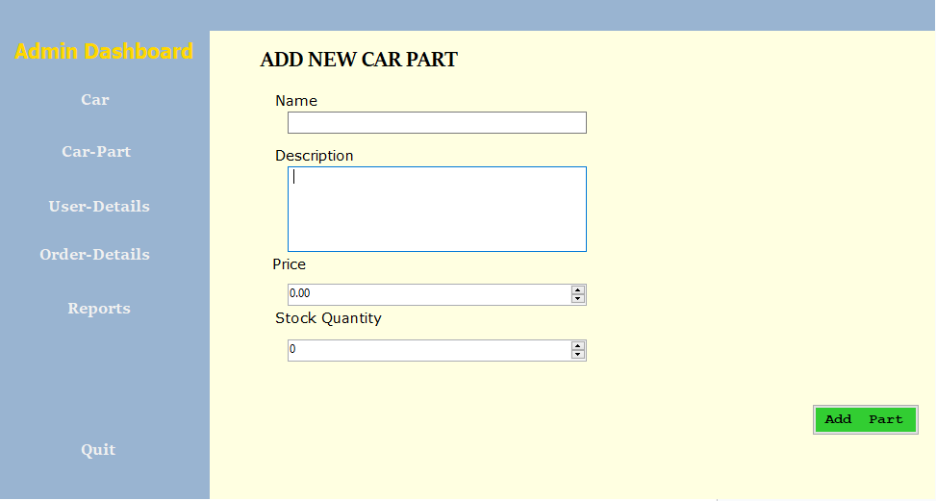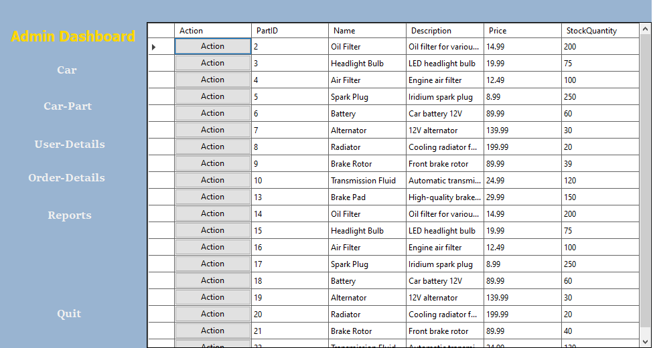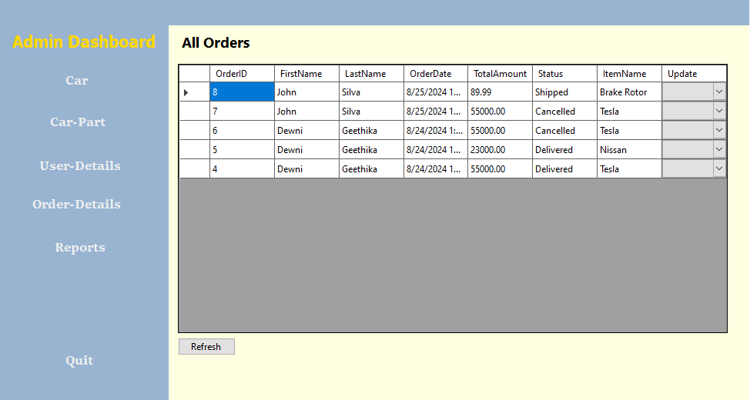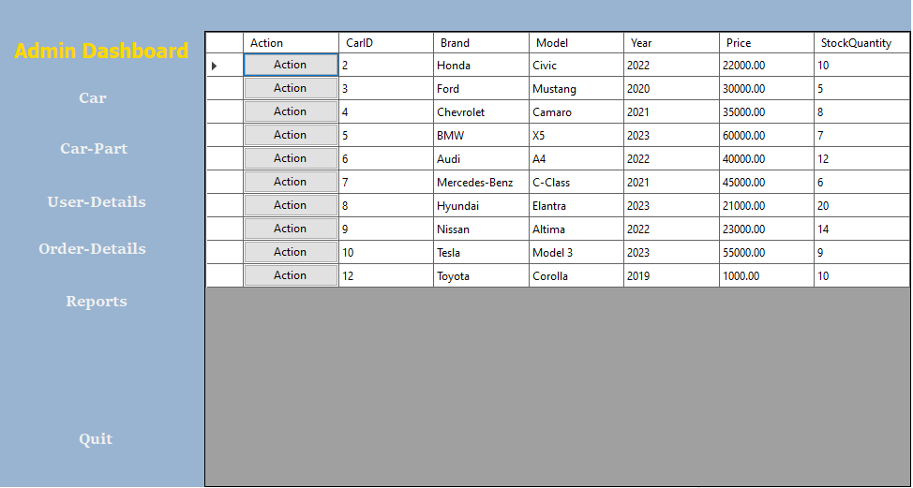

The above screenshots are admin-side views such as adding a new car, view car details, adding a new car part, viewing car part details, user details, order details, and report generations.

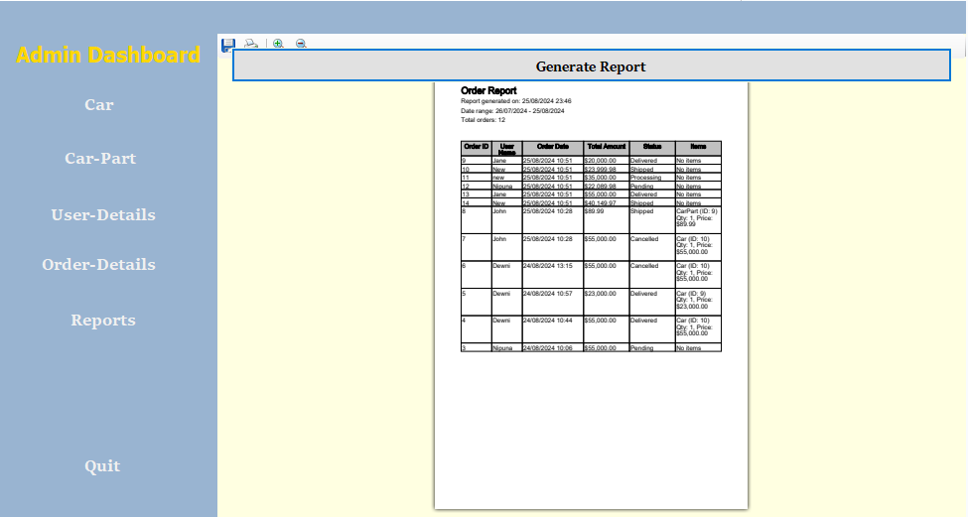
The screenshots are relevant for the search item view and order details view.

Conclusion
This project to manage the car dealership's management system has been a significant learning opportunity. Implementing user authentication, inventory control, order processing, and reporting features are substantial achievements. The project showed off C# and Visual Studio's ability to create reliable, scalable applications. I learned a lot about database integration, user interface design, and software architecture during development. My difficulties, especially with intricate database procedures, helped me strengthen my problem-solving abilities and broaden my knowledge of software development concepts. This project has been a significant step in my development as a developer because it has increased my technical skills and my capacity to handle intricate software projects.

